# Lab Exercise: SQL Server Installation

This document is a walkthrough through the process of **installing and configuring MS SQL Server 2016 LocalDB and Microsoft SQL Server Management Studio**. After following all steps you will have fully installed and configured MSSQL and SSMS.

This lab is part of the [“Software Technologies” course @ SoftUni](https://softuni.bg/courses/software-technologies).

## Download MS SQL Server

Download **Microsoft SQL Server 2016 Express** from: <https://www.microsoft.com/en-us/download/details.aspx?id=52679>.

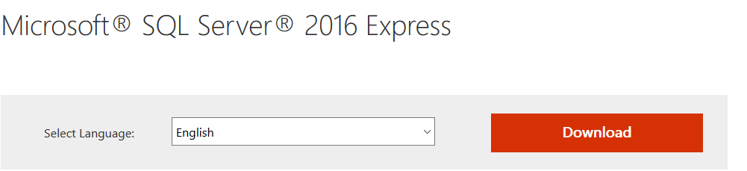

## Install MS SQL Server 2016 LocalDB

In this course we shall use [SQL Server 2016 Express LocalDB](https://msdn.microsoft.com/en-us/library/hh510202.aspx?f=255&MSPPError=-2147217396). This is a lightweight **free** version of SQL Server.

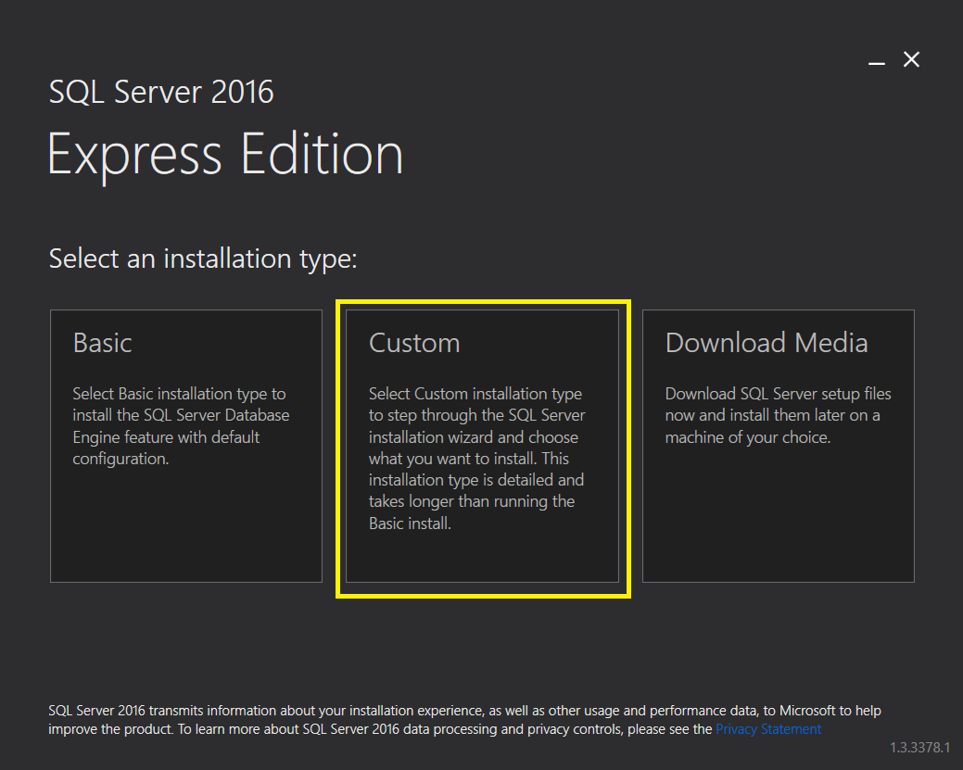

After choosing **Custom** the installer will start the SQL Server Installation Center, that looks like this:

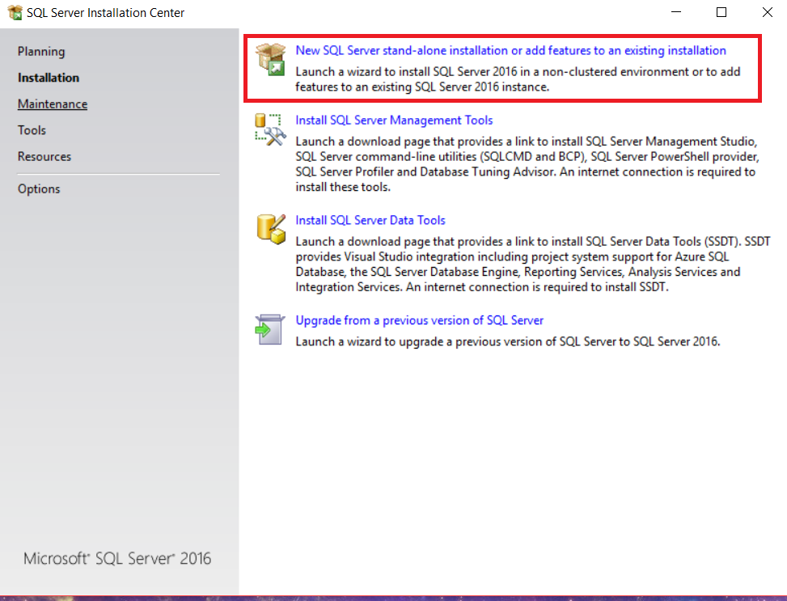

Click on the first option. A new installer will come up. It should look like this:

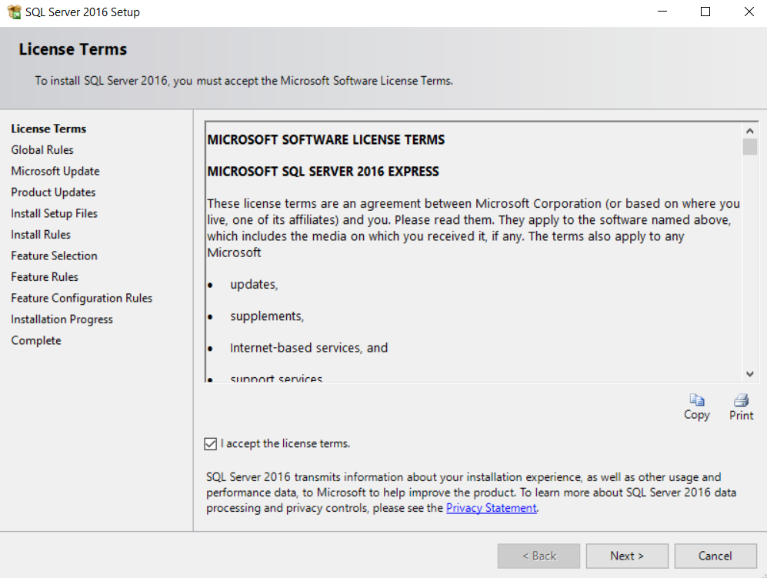

Click **Next**.

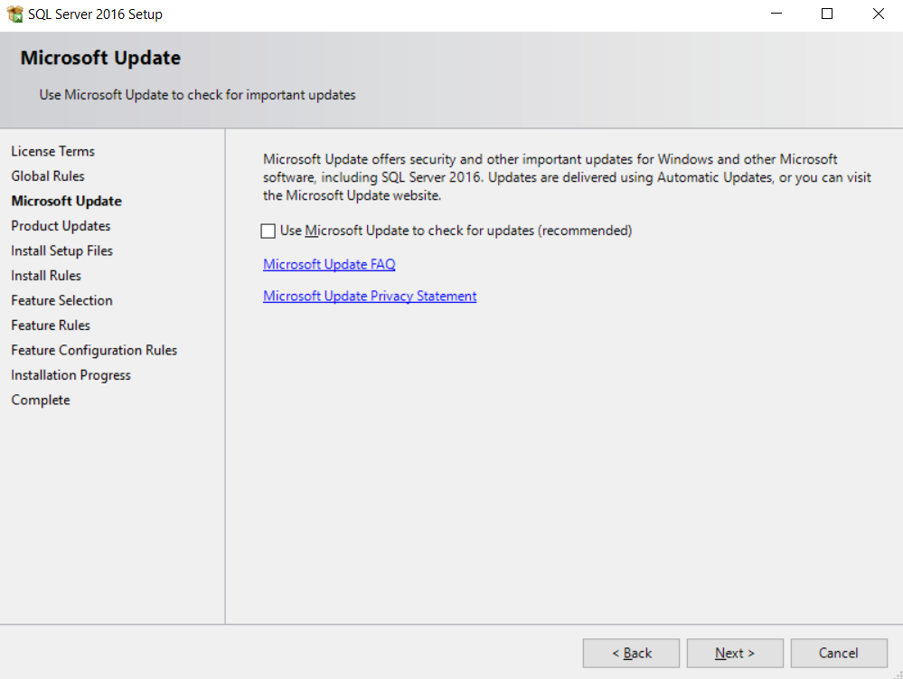

**Next**

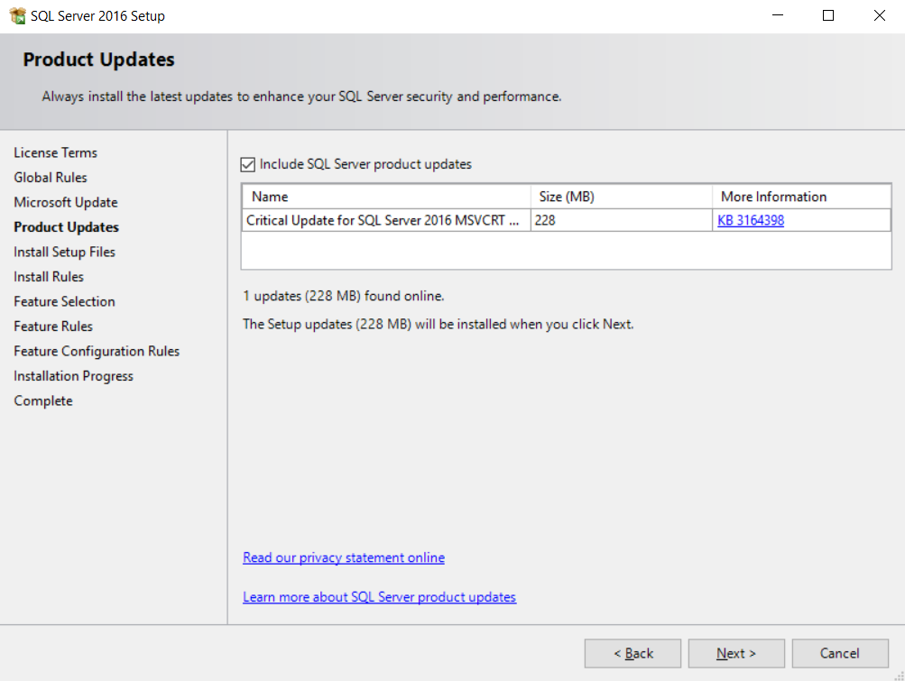

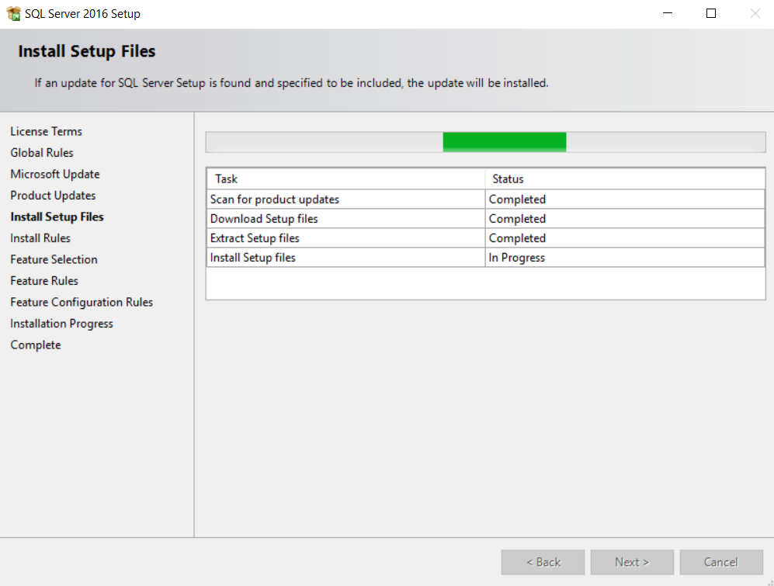

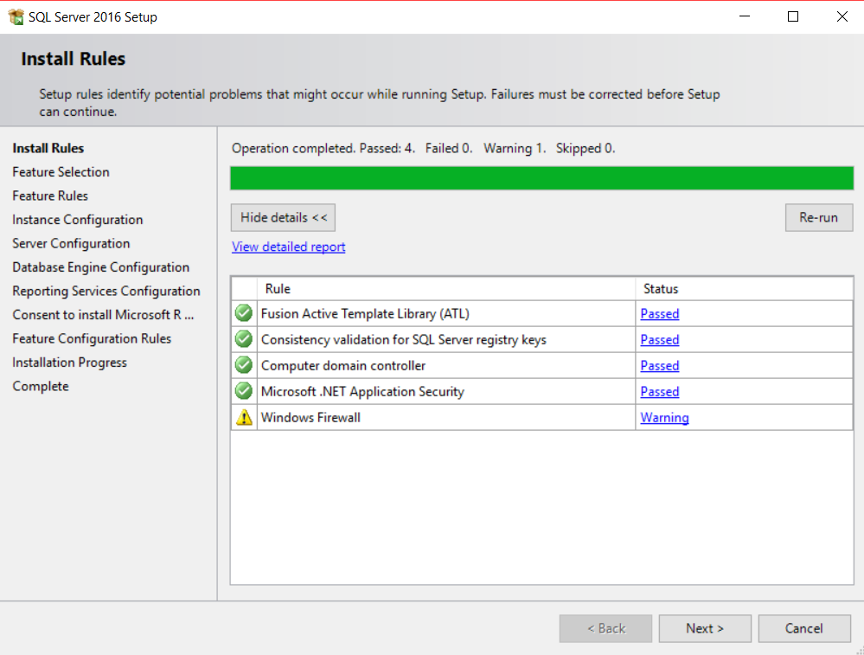

Check the **LocalDB**. It is the only required component for our training course.

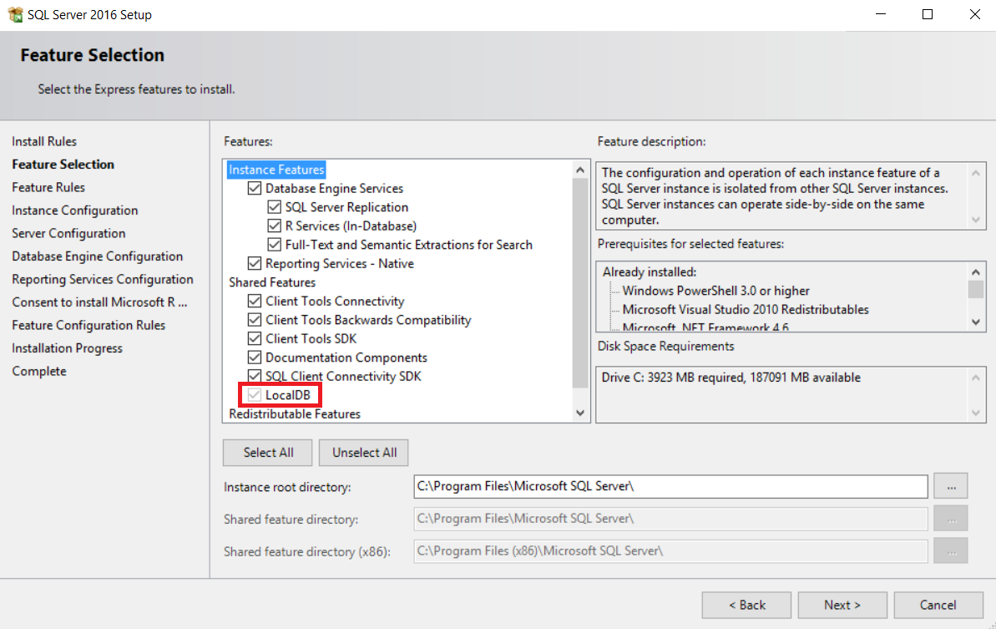

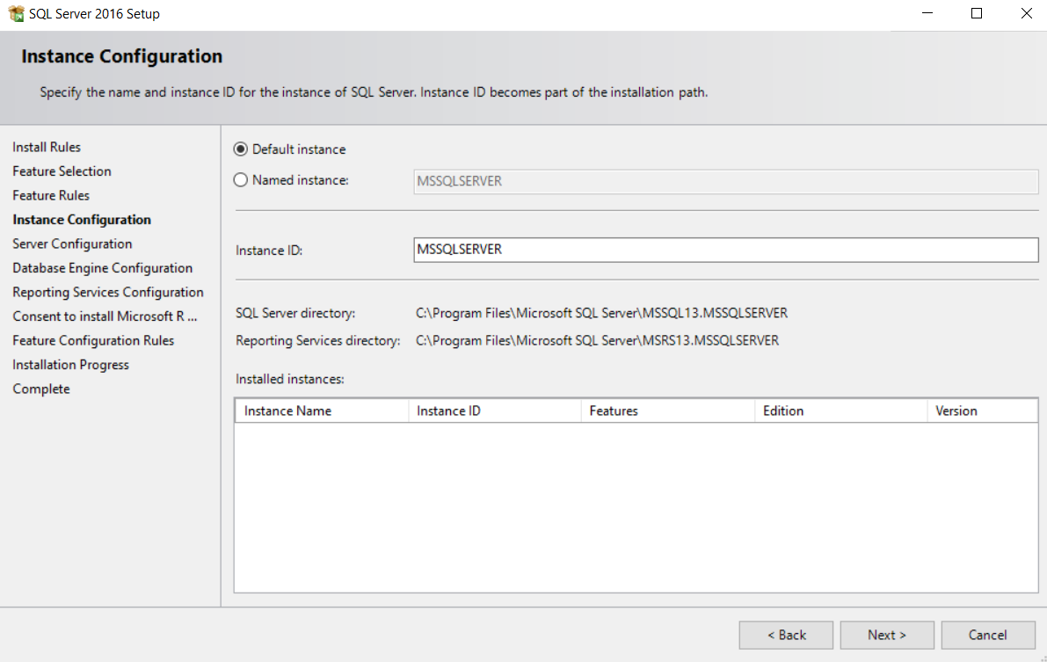

To save memory and Windows startup time, choose **[Manual] Startup Type** for all components.

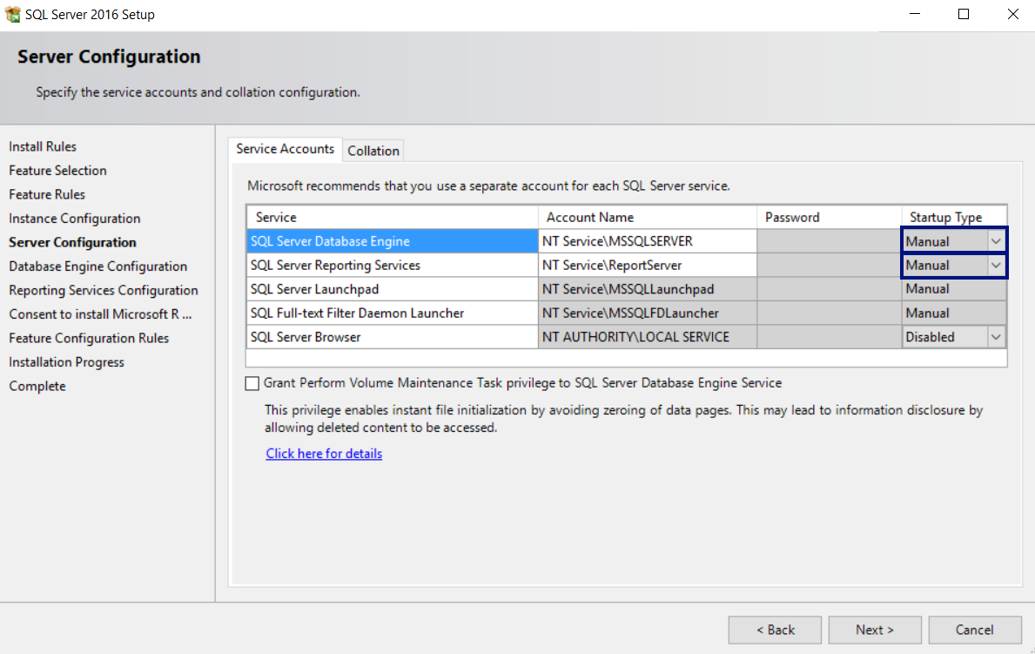

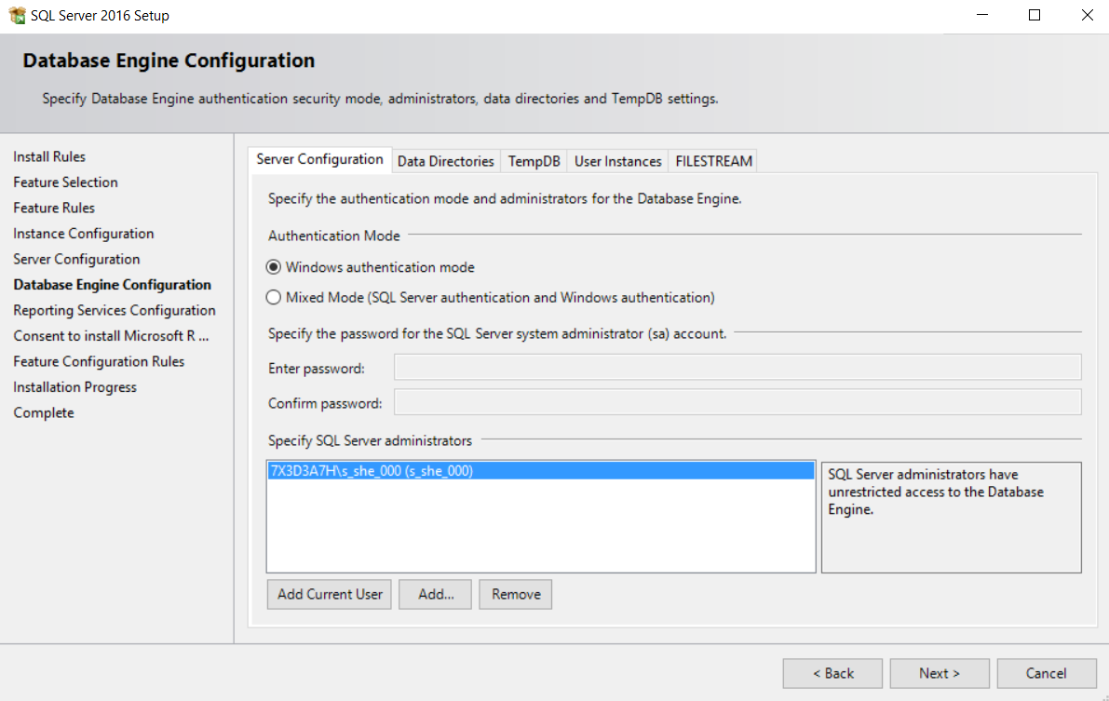

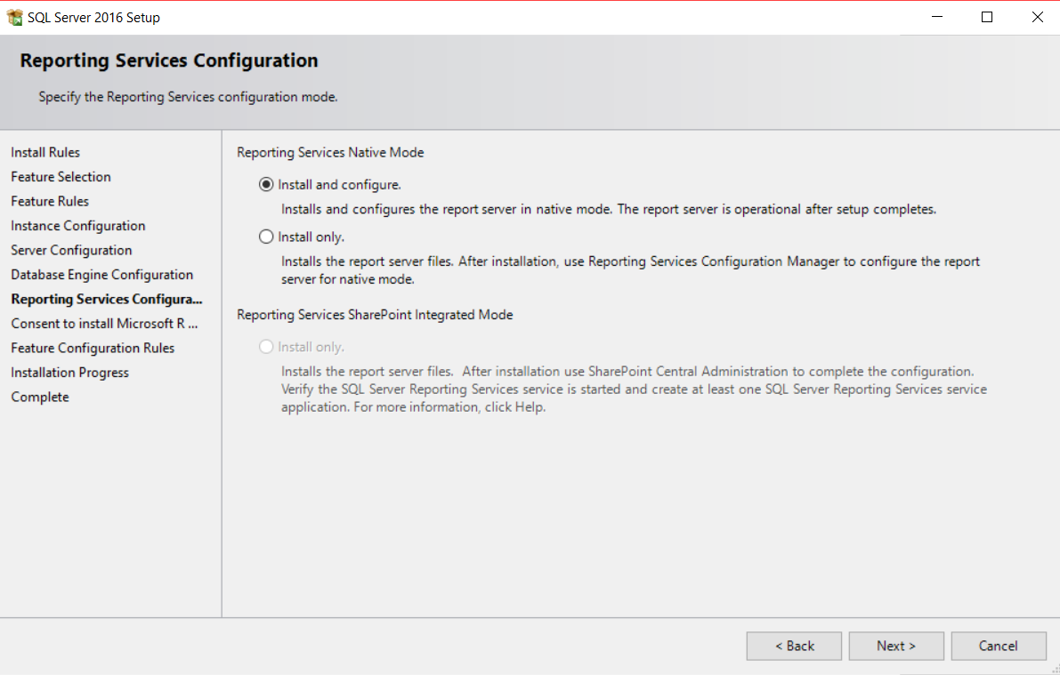

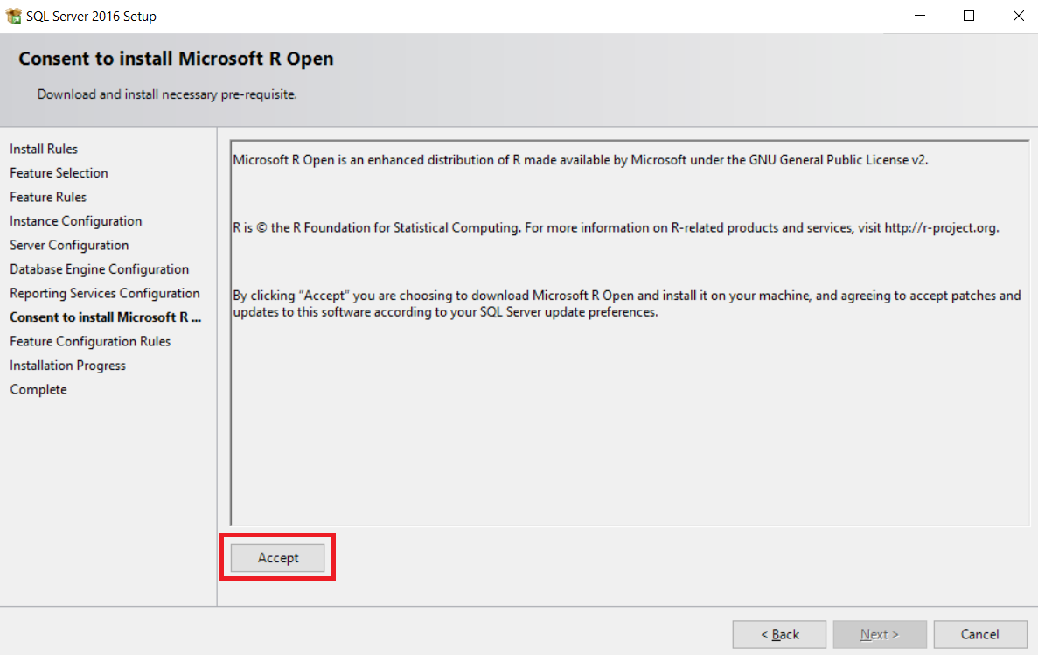

After clicking on **Next** the installation will start.

**Note**: During the installation, you may receive error, which you can simply ignore. It will result in installation fail for the reporting services, but don’t worry, we don’t need them.

That is all, now you have fully installed MS SQL Server 2016.

## Download and Install SQL Server Management Studio (SSMS)

Download **Microsoft SQL Server Management Studio** from here: <https://msdn.microsoft.com/en-us/library/mt238488.aspx>. Don’t use “**SSMS July 2016**” version. It is **broken** and does not work!

The installation will start from this window:

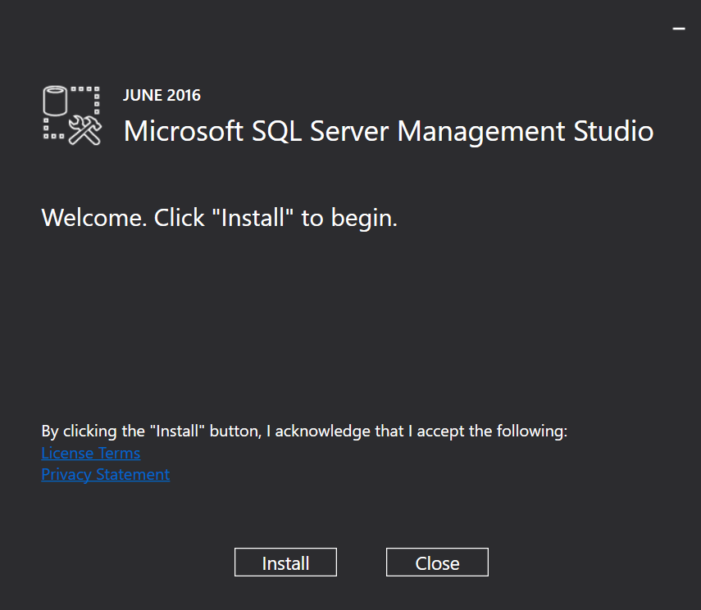

And the end result should be this:

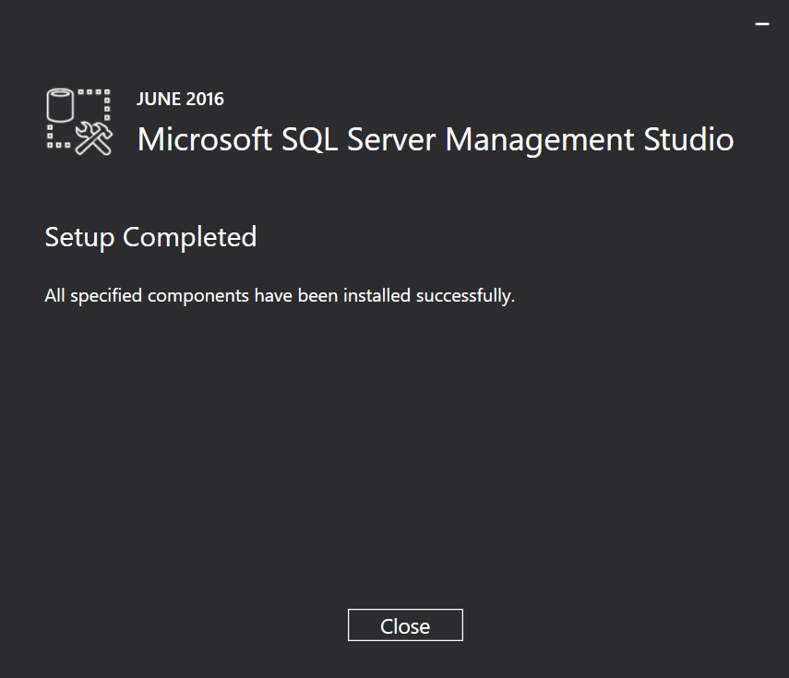

Now we should be ready to start SSMS for the first time.

## Start Management Studio (SSMS)

The first time you start Microsoft **SQL Server Management Studio**, you should see this screen:

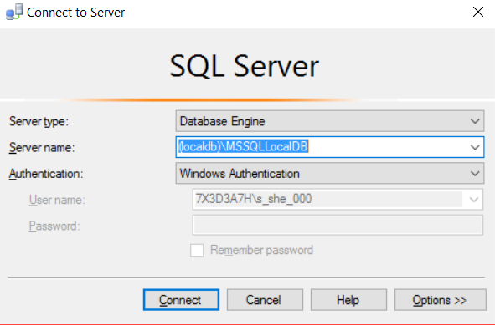

Use the following server name to connect to **MSSQLLocalDB** instance in the **LocalDB**:

|  |
| --- |
| **(localdb)\MSSQLLocalDB** |

After successful connection to the LocalDB, you should see this screen:

